Purpose of the document: To help users setup their Windows Desktop as a 2 Factor Authentication Token using the APL Authenticator

Pre-Requisites:

1. System with Internet Connectivity

Step 1:

From your browser open <https://pwauth.asianpaints.com/>. On the login page enter your credentials and Submit. You will receive the ‘Seed’ via email.

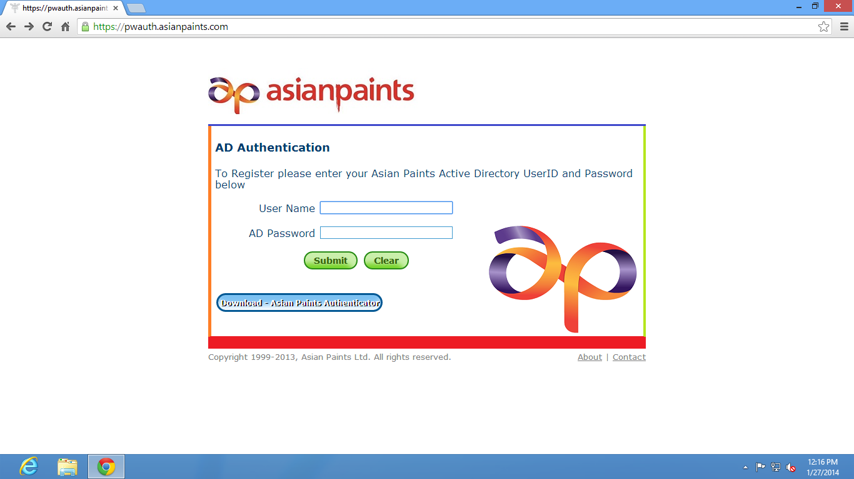

Step 2:

Click on Download Token tab and download the appropriate client for your Desktop. In your case download **APL Authenticator for Windows**.

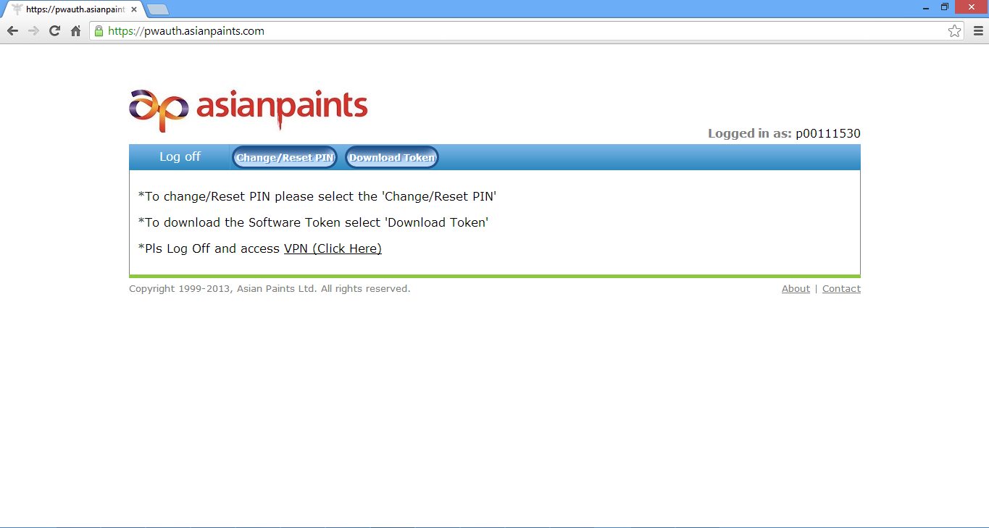

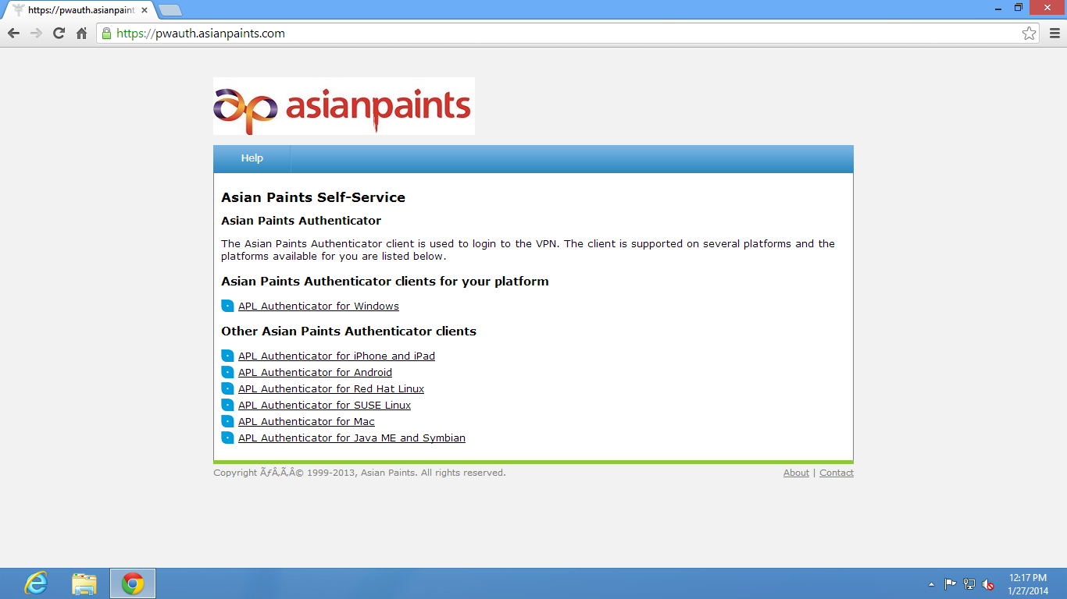

If you are an Asianpaints employee, please ask Wipro team for APL authenticator installation as it requires admin credentials.

Step 3: From the mail which you have received, copy the seed value which is a set of 20 letters (separated into 4 sections of 5 letters each by a hyphen).

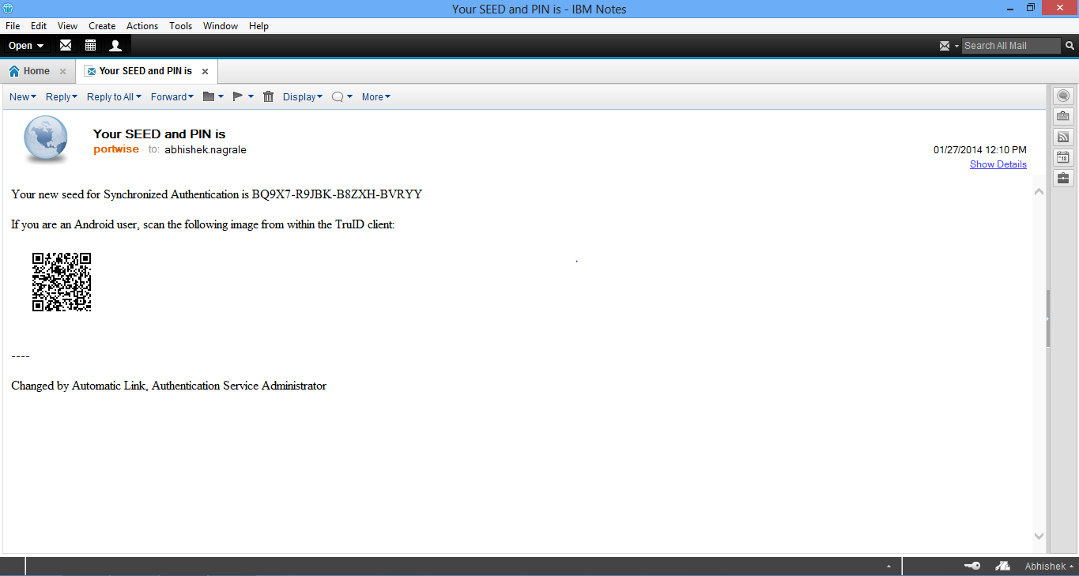

*You would have also got another email with the PIN. Keep this email for future reference.*

Step 4: Start the APL Authenticator client and upon first time use click on the ‘Advanced’ button at the bottom

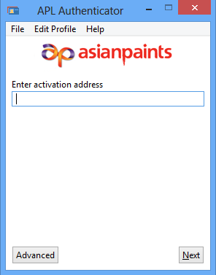

Step 5: This screen will prompt you for the Profile name and the ‘Seed’. Enter the Profile name as APL and paste the seed value copied from your email.

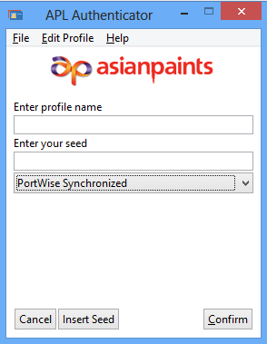 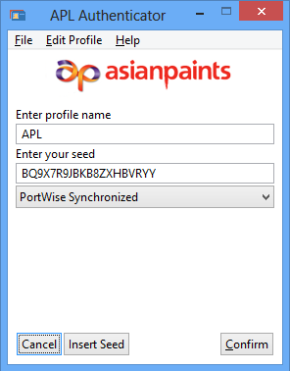

Click on Confirm. This completes the installation and activation of the token and it is now ready to provide the “Second password” for connecting to Asian Paints resources requiring 2 Factor Authentication

Step 5: When connecting to the Asian Paints VPN using Cisco Any Connect Secure Mobility client, type in the address as link.asianpaints.com

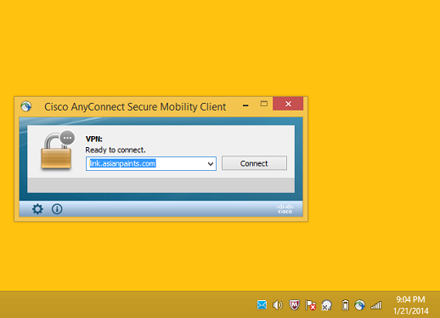

Click on Connect.

Step 6:

Provide your username and password which would have been emailed to you by Asian Paints IT. If you are an employee, enter your Egloo credentials here.

For the “Second Password”, start the APL Authenticator client on your desktop and enter the 6 digit PIN that was emailed to you. This will generate an OTP as below:

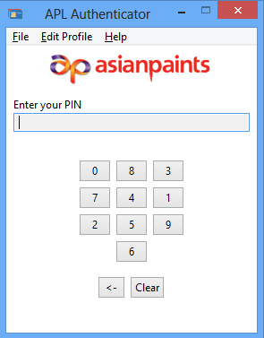 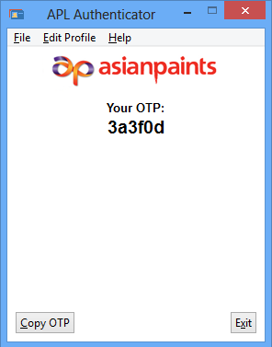

Enter this OTP as the “Second Password”.

Click on “OK”.

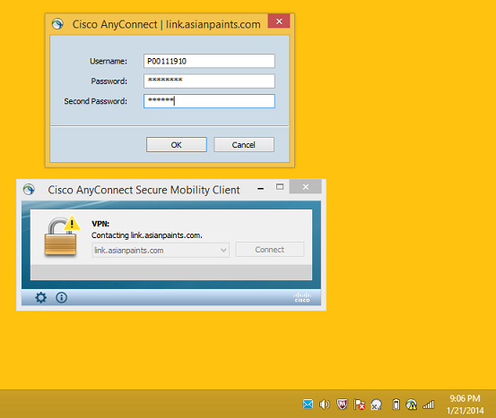

You should now see the following message:

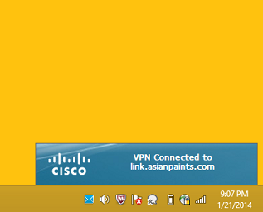

You will now have access to the resources that have been provisioned for your account.

------------------------------------------------------------------------------------------------------------------------------------------